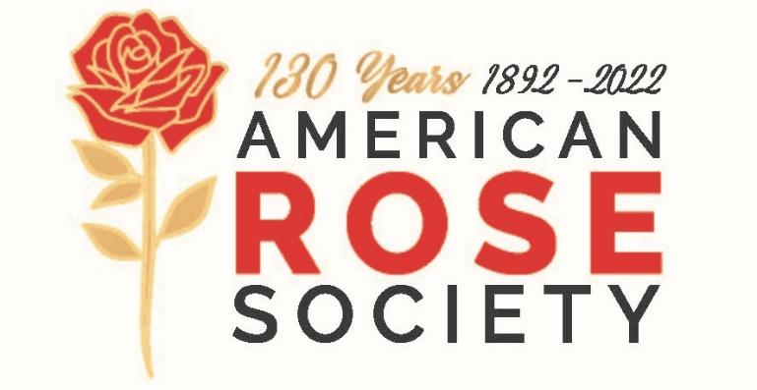

1-800-637-6534

FOR IMMEDIATE RELEASE

Rose Society announces Name Name is certified
as a Consulting Rosarian by the American Rose Society

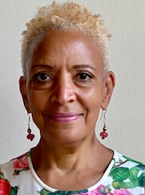
City, ST - Sandra Friend, a rose enthusiast and exhibitor, has studied rose care and grown a diversity of roses for the past eight years. She received hands-on training and mentorship from the local Arlington Rose Foundation. She continued her rose training at the national level, including topics in fertilization, product safety, disease identification and ethics. Sandy was tested and passed her examination in March, 2022. Put your own copy here.
Her interests include teaching rose growing skills and exhibiting roses in competition. Sandy states, “I'm honored to be a certified Consulting Rosarian. I look forward to working with Arlington Rose Foundation members and the public to share educational content through programs and events that exemplify our love of roses.” Include a good quote from the new CR.
An American Rose Society Consulting Rosarian is trained to provide important information on rose culture. They willingly and enthusiastically share their time and talent with new and advanced rose growers. An ARS Consulting Rosarian can help you address almost any question you may have about rose growing, rose care, rose pests and disease management. With rose questions, you can find one by visiting www.rose.org/find-a then scroll to your city and state or contact Sandra at arfinformation@aol.com.

Congratulations to NAME HERE for becoming a leader in rose care education!

Info about your local rose society here… Arlington Rose Foundation, serving northern Virginia, Washington, D.C. and southern Maryland, provides education on all facets of rose growing, photography and design. For more information visit https://arlingtonrose.org

The American Rose Society, headquartered in Shreveport, Louisiana, exists to promote the culture, preservation and appreciation of the Rose, and to improve its standard of excellence for all people, through education and research. For more information on ARS, their Consulting Rosarian Program, or roses in general, visit rose.org

