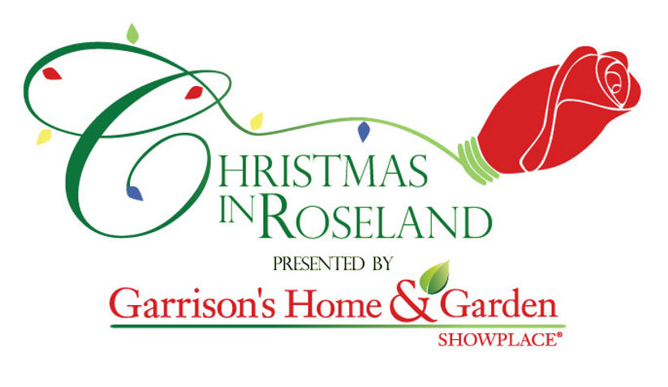

2023 VENDOR AGREEMENT:

This Vendor Agreement is made effective as of , by and The American Rose Society ("The American Rose Society") of 8877 Jefferson Paige Rd, Shreveport, LA 71119 and ("Vendor") of _ (Address).

WHEREAS, The American Rose Society is the organizer and owner of Klima Visitor and Education Center located at 8877 Jefferson Paige Rd, Shreveport, Louisiana 71119 (herein after referred as the 'Building'), where the Roseland Christmas Market will be conducted; and

WHEREAS, Vendor is engaged in the business of _. NOW, THEREFORE, it is agreed that:
PURPOSE. The American Rose Society agrees to provide Vendor space to conduct the Vendor's business at The American Rose Gardens, at The Roseland Christmas Market. Vendor's use of The American Rose Society’s building is limited to the space selected by The American Rose Gardens as identified prior to the event. In general, Vendor is guaranteed a minimum of 100 square feet of space. Vendor accepts the opportunity to participate as a vendor in the American Rose Society’s building commencing on December 8, 2023, and ending on December 10, 2023. Vendor hereby accepts the following listed conditions and limitations.

HOURS OF OPERATION. The American Rose Society’s area shall remain open from 5:30pm to 9:30 pm each day the Event is in progress, unless The American Rose Society notifies Vendor of other hours of operation.

INSTALLATION AND TEAR DOWN. Vendor shall set up booth and items for sale on December 8, 2022, between 12 pm and 4:00 pm. Vendor shall remove his/her booth and items for sale from the building no later than 10:30 pm on December 10, 2023. Vendors may keep set-up in the American Rose Society’s building over night between December 8, 2023, and December 9, 2023. The American Rose Society will not be responsible for anything lost or stolen if left overnight. The building will be locked.

PAYMENT. Vendor is provided with the Space in the Building in exchange for $150.00 to paid upon signing this Agreement. Space locations will be assigned by The American Rose Society and provided to Vendor in advance of the Event. Any Vendor requesting electricity for their set up will need to pay an additional $10.00 for this service.

APPEARANCE. Vendor is responsible for cleaning and maintaining the Space provided in an organized and neat manner. This responsibility includes Vendor's responsibility to remove bulk trash. Should Vendor fail to keep the Space in an orderly manner will result in additional removal fees.

EXTRA SERVICES. The American Rose Society is not obliged to provide telephone, internet, water, electrical, and drain services to Vendor. Vendor shall also be responsible for payment of other charges like, electricity charges, water charges, taxes, etc. to the concerned authorities. The American Rose Society will offer electricity to Vendors that ask for the service beforehand. There will be an additional $10 charge for any Vendor requesting electricity and you will be required to bring your own cord.

DISPLAYS AND SIGNS. All displays in the building must be free standing. Nothing may attach to walls or columns of the building by any means at all. Signs must be free standing. Signs should not block other vendor's shops. Signs may not attach to the walls or columns of the building.

QUALITY PRODUCTS. Vendor shall ensure proper quality of the products sold. Vendor shall comply with all applicable laws as to vendor's sales.

EMPLOYMENT OF STAFF. Vendor will employ adequate staff at Vendor's own cost in order to operating the Space provided by The American Rose Society.

FOOD AND BEVERAGES. No food or beverage may be brought into the Building by Vendor from outside. Vendor shall purchase all foods and beverages from facilities provided for the event.

INSURANCE. Vendor assumes full responsibility for items left in the facility. The American Rose Society is not liable for lost, stolen or damaged property and is not required to carry additional insurance to cover Vendor's property.

INDEMNIFICATION. Vendor agrees to indemnify and hold The American Rose Society harmless from all claims, losses, expenses, fees including attorney fees, costs, and judgments that may be asserted against The American Rose Society that result from the acts or omissions of Vendor and/or Vendor's employees, agents, or representatives or independent contractor.

DEFAULT. The occurrence of any of the following shall constitute a material default under this Agreement:

The failure to make a required payment when due.
- The insolvency or bankruptcy of either party.

- The subjection of any of either party’s property to any levy, seizure, general assignment for the benefit of creditors, application or sale for or by any creditor or government agency.

- The failure to make available or deliver services in the time and manner provided in this Agreement.

REMEDIES. In addition to any and all other rights a party may have available according to law, if a party defaults by failing to substantially perform any provision, term or condition of this Agreement (including without limitation the failure to make a monetary payment when due), the other party may terminate the Agreement by providing written notice to the defaulting party. This notice shall describe in sufficient detail the nature of the default. The party receiving such notice shall have 6 days from the effective date of such notice to cure the default(s). Unless waived by a party providing notice, the failure to cure the default(s) within such time period shall result in the automatic termination of this Agreement.

FORCE MAJEURE. If performance of this Agreement or any obligation under this Agreement is prevented, restricted, or interfered with by causes beyond either party's reasonable control ("Force Majeure"), and if the party unable to carry out its obligations gives the other party prompt written notice of such event, then the obligations of the party invoking this provision shall be suspended to the extent necessary by such event. The term Force Majeure shall include, without limitation, acts of God, fire, explosion, vandalism, storm or other similar occurrence, orders or acts of military or civil authority, or by national emergencies, insurrections, riots, or wars, or strikes, lockouts, work stoppages, or other labor disputes, or supplier failures. The excused party shall use reasonable efforts under the circumstances to avoid or remove such causes of non-performance and shall proceed to perform with reasonable dispatch whenever such causes are removed or ceased. An act or omission shall be deemed within the reasonable control of a party if committed, omitted, or caused by such party, or its employees, officers, agents, or affiliates.

ARBITRATION. Any controversies or disputes arising out of or relating to this Agreement shall be resolved by binding arbitration in accordance with the then-current Commercial Arbitration Rules of the American Arbitration Association. The parties shall select a mutually acceptable arbitrator knowledgeable about issues relating to the subject matter of this Agreement. In the event the parties are unable to agree to such a selection, each party will select an arbitrator and the two arbitrators in turn shall select a third arbitrator, all three of whom shall preside jointly over the matter. The arbitration shall take place at a location that is reasonably centrally located between the parties, or otherwise mutually agreed upon by the parties. All documents, materials, and information in the possession of each party that are in any way relevant to the dispute shall be made available to the other party for review and copying no later than 30 days after the notice of arbitration is served. The arbitrator(s) shall not have the authority to modify any provision of this Agreement or to award punitive damages. The arbitrator(s) shall have the power to issue mandatory orders and restraint orders in connection with the arbitration. The decision rendered by the arbitrator(s) shall be final and binding on the parties, and judgment may be entered in conformity with the decision in any court having jurisdiction. The agreement to arbitration shall be specifically enforceable under the prevailing arbitration law. During the continuance of any arbitration proceeding, the parties shall continue to perform their respective obligations under this Agreement.

ENTIRE AGREEMENT. This Agreement contains the entire agreement of the parties, and there are no other promises or conditions in any other agreement whether oral or written concerning the subject matter of this Agreement. This Agreement supersedes any prior written or oral agreements between the parties.

SEVERABILITY. If any provision of this Agreement will be held to be invalid or unenforceable for any reason, the remaining provisions will continue to be valid and enforceable. If a court finds that any provision of this Agreement is invalid or unenforceable, but that by limiting such provision it would become valid and enforceable, then such provision will be deemed to be written, construed, and enforced as so limited.

AMENDMENT. This Agreement may be modified or amended in writing, if the writing is signed by the party obligated under the amendment.

GOVERNING LAW. This Agreement shall be construed in accordance with the laws of the State of Louisiana.

NOTICE. Any notice or communication required or permitted under this Agreement shall be sufficiently given if delivered in person or by certified mail, return receipt requested, to the address set forth in the opening paragraph or to such other address as one party may have furnished to the other in writing.

WAIVER OF CONTRACTUAL RIGHT. The failure of either party to enforce any provision of this Agreement shall not be construed as a waiver or limitation of that party's right to subsequently enforce and compel strict compliance with every provision of this Agreement.

ASSIGNMENT. Neither party may assign or transfer this Agreement without the prior written consent of the non-assigning party, which approval shall not be unreasonably withheld.

SIGNATORIES. This Agreement shall be signed on behalf of The American Rose Society by Claire Bissell, Interim Executive Director, and on behalf of Vendor (_ _) by
_, Manager and shall be effective as of the date first written above.

