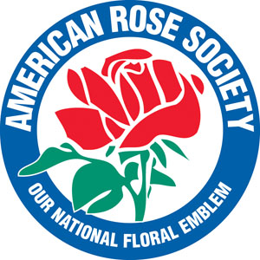
NEWS RELEASE

American Rose Society
P. O. Box 30,000 Shreveport, LA 71130-0030
8877 Jefferson Paige Road Shreveport, LA 71119-8817
Phone: 318-938-5402 Fax: 318-938-5405 www.rose.org

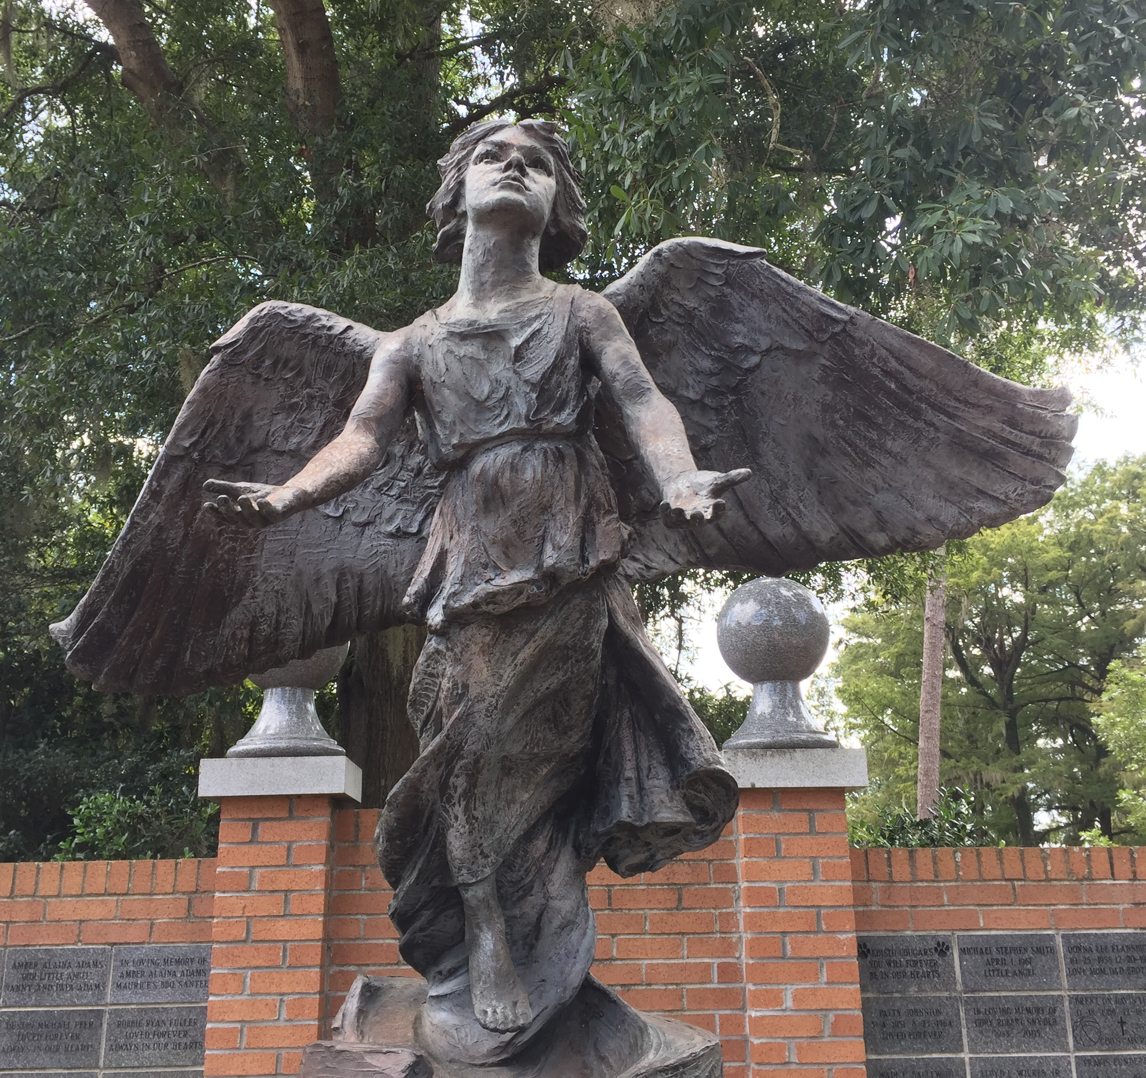
August 7, 2019
Media Contact: Jon Corkern, Executive Director
ExecutiveDirector@rose.org, 318-938-5402

An Angel for America’s Rose Garden
Shreveport, LA — The dedication of the Angel of Hope monument and newly installed Angel Garden will be held at the American Rose Center on Friday, Sept. 6 at 6:00 pm. The event is free and open to the public.

The Angel of Hope sculpture, sometimes known as the Christmas Box Angel statue, was introduced to the world in the book The Christmas Box, a world-wide bestseller by Richard Paul Evans. In the book, a woman mourns the loss of her child at the base of an angel monument. Though the story is mostly fiction, the angel monument once existed but is speculated to have been destroyed. The angel statue was commissioned by Richard Paul Evans and sculpted by the father and son team, Ortho and Jared Fairbanks of Salt Lake City, Utah. Ortho and his wife lost a child and found great significance in the statue.

There are more than 120 Angel sculptures in garden sites around the U.S. and abroad; the sites are gathering places for parents, families and friends to remember children who have been lost. Candlelight ceremonies are held on Dec. 6 of every year at each of these locations, the date the first monument was dedicated and corresponding with the date of the child’s death in The Christmas Box.

A generous gift has been received for America’s Rose Garden for the purpose of purchasing and installing the Angel of Hope sculpture. The bronze sculpture measures 4’3” tall with a wingspan of 5’2”. It will be in installed in a serene setting of towering pines in the tranquil section of the America’s Rose Garden that will be known as the Angel Garden.

The first annual candlelight ceremony at America’s Rose Garden will be held at the Angel of Hope sculpture at 6 p.m. on Dec. 6, 2019.

Photo will be available for media use at www.rose.org/press.

The American Rose Society is a non-profit, educational organization working to promote the beauty, culture and preservation of the rose. Their headquarters home, the American Rose Center – “America’s Rose Garden”, features more than 7,000 roses. The American Rose Center, located at 8877 Jefferson Paige Road in Shreveport, LA, is open Monday through Saturday, 9 a.m. to 5 p.m. and Sunday, from 1 p.m. to 5 p.m. Each year on the weekend following Thanksgiving, the American Rose Center hosts Christmas in Roseland. 2019 marks the 36th year and runs each Friday, Saturday and Sunday, Nov. 29 through Dec. 15. This year we will be open for special encore nights on Monday Dec. 16 through Sunday Dec. 22.

